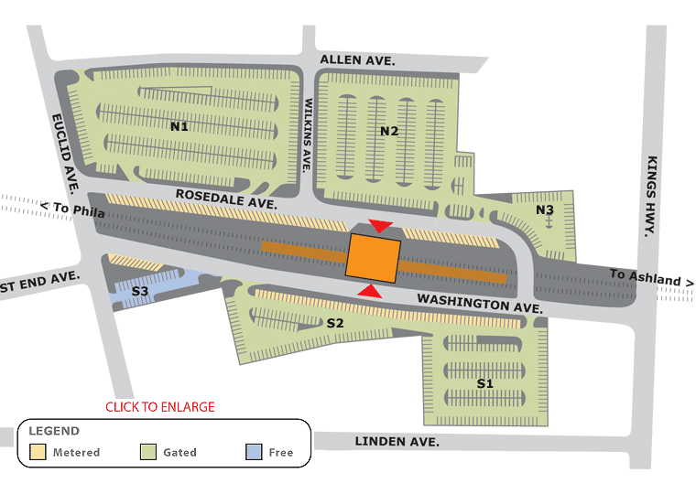
HADDONFIELD PARKING LOT REPAVING SCHEDULE
LOTS S1 & S2
Scheduled for repaving
5/31 – 6/3
Weather permitting
LOTS N2 & N3
Scheduled for repaving
6/6 – 6/10
Weather permitting
LOTS N1 & S3
Scheduled for repaving
6/13 – 6/17
Weather permitting

